Request for change for the plugin: Micro Focus Application Automation Tools
Currently the configuration for this plugin has the parameter “Test Folder” and it is defined as follows:
The path of the test folder that will contain the uploaded test. The path doesn't include the Root test folder (Subject).
For example, sampletestfolder\subfolder means, the tests will be uploaded to test folder named 'subfolder', which is under the test folder named 'sampletestfolder',
and 'sampletestfolder' is under the root test folder 'Subject'.

The configuration of this parameter does NOT allow to upload tests cases in different subfolders.
Let me explain it with an example:
Our current project structure is someone like that:
Root/
- Automated tests/
  - Module 1/
    - Test A
    - Test B
  - Module 2/
    - Test C
  - Module 3/
    - Test D
Let’s imagine that we have configure Jenkins like that:
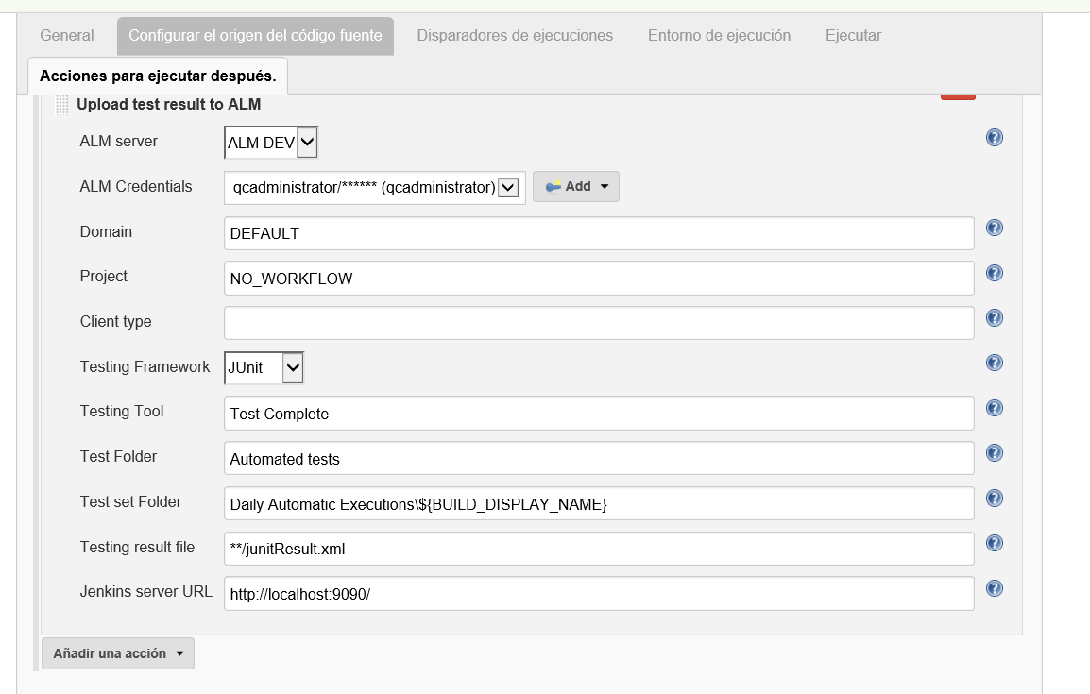

When we made an execution, the plugin upload the tests like follows:
Root/
- Automated tests/
  - Test A
  - Test B
  - Test C
  - Test D
  - Module 1/
    - Test A
    - Test B
  - Module 2/
    - Test C
  - Module 3/
    - Test D

In this case, we want to avoid the duplication of these test cases.
We think that this is a very common situation where typically test cases are defined in different folders to have a better organizations, so the plugin should be able to localize them in the hierarchy.

